Vendor Portal & Inventory Management System



Singer India Ltd

Software Requirement Specification (SRS)

Project ID:

BAR CODE INDIA, 145 Udyog Vihar Phase 1, Gurugram, Haryana-122016, PH: 0124 4337555

**Submission Date: 27- 02-2023**

**Version: 1.0**

**Prepared By: Omkar, Leena**

The document details the summary of solution architecture and approach for the development of Vendor Portal & Inventory Management System for Singer India Ltd. The document is based on the inputs, system study, discussions and meeting held between BCI & Singer India Ltd. Teams.

BAR CODE INDIA, 691 Udyog Vihar Phase V, Gurugram, Haryana-122016, PH: 0124 4337555

|  |  |  |  |  |
| --- | --- | --- | --- | --- |
| REVISION NO. | DATE | PREPARED BY | REVIEWED BY | COMMENT |
| 1.0 | 27-02-2023 | Omkar, Leena | Ashutosh Kroria | SRS Document for Singer India Ltd |

REVISION HISTORY

**Abbreviations:**

|  |  |
| --- | --- |
| **Name** | **Abbreviation** |
| Singer India Ltd. | SIL |
| Bar Code India | BCI |
| Handheld Terminal | HHT |
| Purchase Order | PO |
| Microsoft Navision | Microsoft Business Center |

Table of Contents

1 Specification Organization 2

2 Introduction 3

2.1 Intended Audience and Reading Suggestions 3

2.2 Business Requirements 4

2.3 Business Challenges 4

2.4 Project Scope 4

2.5 Functional Scope 6

2.6 ERP Interface: 6

3 Software/Hardware Requirements 7

3.1 Central Server Configuration/Database Servers 7

3.2 Desktop Computers Configuration 7

3.3 Hardware 7

4 Solution Architecture 8

5 User Interface Specification Conventions 9

6 System Log 10

6.1 Error Logs 10

6.2 Audit Logs 10

7 Architectural Design 11

7.1 Vendor Web Application 11

7.2 Device Application 11

7.3 Communication Server 11

8 Application Modules 12

8.1 User Management 12

8.1.1 User Master 12

8.1.2 User Rights/ Permission 13

8.2 Masters 14

8.2.1 Material Master 14

8.2.2 Vendor Master 14

8.2.3 Customer Master 15

8.2.4 Label Master 15

8.2.5 Warehouse master 16

8.2.6 Plant Master 16

8.2.7 BOM Master 17

8.2.8 Purchase Order Master 18

8.2.9 Purchase Order Posting Master 18

8.2.10 Sales Order Master 19

8.2.11 Sales Order Posting Master 19

8.2.12 Warranty Replacement Master 19

8.2.13 Sales Return Master 20

8.2.14 Vendor Return Master 21

8.3 Vendor Portal 22

8.3.1 Order Download 22

8.3.2 Label Printing- Primary Carton Printing 24

8.3.3 Label Printing- Master Carton Printing 26

8.3.4 Master Carton Mapping 28

8.3.5 Dispatch 30

8.4 Warehouse Operation 33

8.4.1 Receiving 33

8.4.2 Location Marking 34

8.4.3 Putaway 35

8.4.4 Picklist Creation 36

8.4.5 Picking 37

8.4.6 Dispatch 39

8.4.7 Sales Return 40

8.4.8 Warehouse Transfer 42

8.4.9 Vendor Return 43

8.5 Reports 45

9 SRS Scope Change Process 46

9.1 Before Sign Off 46

9.2 After Sign Off 46

9.3 SRS Acceptance 46

# Specification Organization

The objective of this document is to supply underlying concepts, procedures, and formats used in the design, development and installation of this software application. This specification consists of three sections organized as follows:

**Section 1: Introduction**

This section provides hardware requirements and documentation conventions.

**Section 2: User Interface**

This section depicts screen design and logic flow, and is categorized into two groups:

* Application Function Module
* Common Routine

**Section 3: System Architecture**

This section provides information of system architecture.

# Introduction

## Intended Audience and Reading Suggestions

The scope of this document is to provide the understanding of this solution to user & development teams associated with the application development & implementation.

This document major emphasizes on providing clear understanding of Traceability System.

This solution comprises of:

* Web Application
* Android Device Application
* Communication Server
* Scheduler Application

## Business Requirements

Singer India Ltd. is currently looking for the automated system to keep track of their Products movement from multiple Vendors to their Warehouses. The company also wants to manage their warehouse inventory.

BCI has studied and analyzed the Singer India Ltd. existing process in depth and understands its requirement. In order to overcome the problems and challenges faced during products movement, BCI would like to propose the solution which will help in the automation and tracking of items from Vendors to Warehouses. The solution provides infallible data updating, integrity, data accuracy and eliminates above stated problems.

## Business Challenges

The challenges faced by the Singer India Ltd. in performing their day-to-day operation are as follows:

* Manual dependency for products identification.
* Managing 450+ items movement amongst 22 Warehouses and 60 Vendors is quite difficult
* Difficult to manage warehouse inventory
* Keeping track of return inventory is cumbersome task
* Difficult to manage items dispatch
* Manual dependency to validate the items during dispatch leads to higher chances of wrong delivery.
* Orders are maintained in Navision
* Data is being recorded in excels/ files etc.
* Manual data is being updated in Navision.
* Items tracking is done through excel sheets and Navision.

## Project Scope

The scope of the application is to create Vendor Portal & Inventory Management System which will help in managing items movement from Vendors to warehouse as well as manage warehouse inventory using AIDC Technology.

The solution requires the development of web-based application for Vendors and Warehouse to make the day-to-day operations effective and efficient.

**Vendor Portal**: The portal will provide procedures to receive orders, help control the movement, packing and dispatch of items (cartons). The application will allow user to print 4 types of Barcode Labels i.e. for Product/ Item, Primary Pack, Master Carton/ MRP and Warranty Card. Items are packed in Master Carton and dispatched against Release Orders to warehouse. The application will keep updating associated transaction data on server in real time.

**Warehouse**: The IMS (Inventory Management System) application will manage inventory at warehouse and keep track of the items received from Vendors and dispatched to regional warehouse/ customers against Release Orders. It also helps in keeping record of sales return items. The application will keep record of each stage and update associated transaction data on server in real time.

The application will be integrated with existing Microsoft Navision in order to get and post required data from Navision and smooth functioning of the application.

Using this application, it is possible to monitor and keep record of the goods flow, analyze inventory and minimizes the risk of good loss/ theft. This will be proved beneficial for SIL as it aims to improve data accuracy, increase processing speed, eliminates paperwork, reduces time & effort required for the activity and provide instant inventory and other types of pertinent reports.

This would require development of **Wi-Fi enabled application for real time transaction**.

## Functional Scope

The scope of the software would require the development of the front end application, client device application and communication server to transfer data from application to server. The document lays down the specifications of the middleware application, its architecture and infrastructure requirements.

The entire solution consists of followings:

* Web Application ( .NET 4.5)
* Mobile Device Application (Android Studio)
* External Interfaces / Integration

## ERP Interface:

The application will be integrated with existing Microsoft Navision

The data will be exchanged using Web service/API provided by client

There will NOT be any integration with Machines/ Third Part Application/ PLC etc.

# Software/Hardware Requirements

Below are the basic requirements for running the proposed application at SIL Site and infrastructure requirements will be taken care by SIL.

## Central Server Configuration/Database Servers

The solution would require the high performance server with minimum of following:

YTD

It is recommended that SIL procure database server with expandable data storage capacity since the volume of data generated would increase with increase in the daily transactions. The exact amount of data generated shall be visible after pilot test of entire cycle of the system.

## Desktop Computers Configuration

The desktop application would require the computer with following specifications:

* i5/i7 Processor with Windows 10 operating System
* 8 Core Processor
* 32 Gb RAM
* SQL Server 2019 Std. Edition
* 1 Tb Storage

## Hardware

* Vendor Site
* Barcode Printer
* Bluetooth Scanner
* Warehouse
* Barcode Printer
* Android Device/ HHT

# Solution Architecture

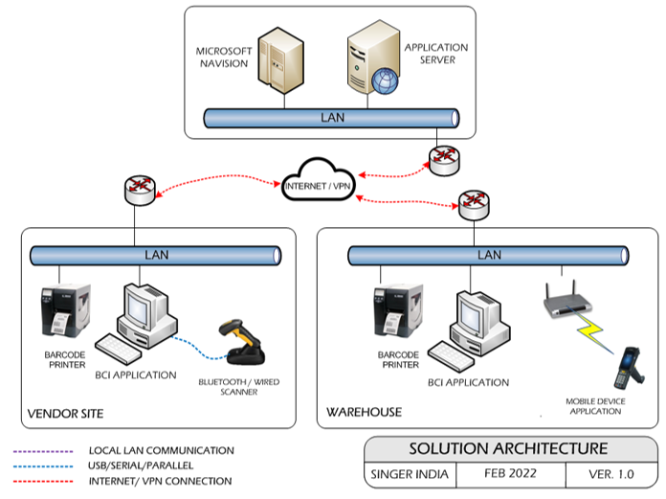

# User Interface Specification Conventions

This section specifies the user interface portion of the application.

**Section Organization**

The User Interface Specification presents screen displays or “**Dialogs**”.

**Documentation Conventions**

This section incorporates illustrations of the application user interface. Each screen display “Dialog” consists of the screen display image, a process name, a paragraph documenting the processing required for the dialog, a paragraph listing the navigation options, and a table listing for each variable field on the dialog, its database source or destination, format, and any instructions required to process the field.

The following section contains a sample dialog with each area identified.

# System Log

System shall maintain internal logs for application.

## Error Logs

These logs will contain any errors encountered during runtime for faster resolution of any problem post deployment.

## Audit Logs

These logs will monitor the activities of user who accessed the application, made changes to File/ Document and the time stamp of these activities.

# Architectural Design

Overall System consists of:

* Vendor Web Application
* Device Application
* Communication Server

## Vendor Web Application

A Web Application will be developed for performing transactions like Order Download, Label Printing Primary and Master Carton Printing, Master Carton Mapping, Dispatch.

## Device Application

This application will include transactions including Receiving, Location Marking, Putaway, Picklist Creation, Picking, Dispatch, sales Return, Warehouse Transfer, Vendor Return etc. Application will directly communicate with user input and process the request to communication server.

## Communication Server

This application will handle the device request in real time. Most of business logic on scanning will run on this module. Communication Server will run on single server with static IP.

# Application Modules

## User Management

The module will let application administrator to manage the Users, and the rights assigned to the same; the rights will define authorized application access of users.

The User Management & Master data will be created using **Web Application.**

### User Master

This module will let user to create application users who will access the application. The master will store the users’ details in system.

|  |  |
| --- | --- |
| **Data Fields** | 1. User ID 2. User Name 3. Description 4. Password 5. Email 6. Address 7. Contact 8. Active/ Inactive |
| **Process Steps** | 1. Enter required details i.e. User ID, User Name, Description, Password in system 2. Email, Address, Contact are optional data fields 3. Check the Active checkbox to make the user active 4. Click on Save button to save details in database 5. Newly added user will appear in data grid |
| **Functions** | 1. Add, Edit/Update, Delete as per requirement 2. User ID and Password is used to access the application. |
| **Role** | Admin will create/ add user details via window application |

### User Rights/ Permission

This module will let admin to assign module / screen access rights to the application users. Once assigned, authorized users can access the application. Once permissions are assigned, user will be able to view only those screens/ modules of which he has been given access rights to by Admin.

|  |  |
| --- | --- |
| **Data Fields** | 1. User ID/ Name 2. Module /Screen Names |
| **Process Steps** | 1. Admin will select User Name/ID. 2. Screen/ module names will appear in data grid along with checkbox. 3. Admin will check the checkbox against module/ screen to which selected User should be assigned access permissions. 4. Save and Update the details in database |
| **Functions** | Add, Edit/Update as per requirement |
| **Role** | Admin / Authorized User will assign access rights to the selected User |

## Masters

### Material Master

The module will be used to view the Material details downloaded from ERP.

|  |  |
| --- | --- |
| **Data Fields** | 1. Material Code 2. Material Description 3. Material Group 4. UOM 5. Color 6. MRP |
| **Process Steps** | 1. Material Master screen will be visible to authorized personnel only 2. BCI application will download Material details from Server 3. Downloaded Material details such as Material Code, Material Description, Material Group, UOM, Color, MRP details will get displayed in data grid on screen. |
| **Functions** | View details of the Material master. |
| **Sample Screen** |  |

### Vendor Master

The module will be used to view the Vendor details which are fetched from ERP.

|  |  |
| --- | --- |
| **Data Fields** | 1. Vendor Code 2. Name 3. Address 4. Contact Number 5. Email |
| **Process Steps** | 1. Vendor Master Screen will be visible to authorized personnel only. 2. BCI application will download Vendor details such as Vendor Code, Name, Address, etc. from Server. 3. Downloaded Vendor details will get displayed in data grid on screen. |
| **Functions** | View details of the Vendor master. |
| **Sample Screen** |  |

### Customer Master

The module will be used to view the Customer details fetched from ERP.

|  |  |
| --- | --- |
| **Data Fields** | 1. Customer Code 2. Name 3. Address 4. Contact No. 5. Email 6. Active/ Inactive |
| **Process Steps** | 1. Customer Master Screen will be visible to authorized personnel only. 2. BCI application will download Customer details such as Customer Code, Name, Address, etc. from ERP. 3. Downloaded Customer details will get displayed in data grid on screen. |
| **Functions** | View details of the Customer master. |
| **Sample Screen** |  |

### Label Master

The module will be used to save the Label details in database. Using this module user can update or delete a Plant details.

|  |  |
| --- | --- |
| **Data Fields** | 1. Material Code 2. Label code 3. Label Color 4. Label Design 5. Label Size |
| **Process Steps** | 1. User will enter Material and Label design. 2. User can enter Label Code, Label size and Design as required as per material code. 3. Save and Update the details in database |
| **Functions** | Add, Edit/Update as per requirement |
| **Role** | Admin / Authorized User will add/edit Plant details. |
| **Sample Screen** |  |

### Warehouse master

The master module will be used to store the Warehouse details in database; each warehouse will have a unique ID.

|  |  |
| --- | --- |
| **Data Fields** | 1. Warehouse ID 2. Warehouse Description 3. Warehouse Address. 4. Active or In-Active |
| **Process Steps** | 1. User will enter Warehouse ID, Description and Address. 2. Select the Warehouse is Active or In-active. 3. Save the details in database. |
| **Functions** | Warehouse details are fetched from these master |
| **Sample Screen** |  |

### Plant Master

The module will be used to save the Plant details in database. Using this module user can update or delete a Plant details.

|  |  |
| --- | --- |
| **Data Fields** | 1. Plant Code 2. Plant Description 3. Stack Label Required |
| **Process Steps** | 1. User will enter Plant code and Description. 2. User can enter Stack Label required as per plant code. 3. Save and Update the details in database |
| **Functions** | Add, Edit/Update as per requirement |
| **Role** | Admin / Authorized User will add/edit Plant details. |
| **Sample Screen** |  |

### BOM Master

The module will be used to view the Bill of Material details downloaded from SAP. Bill of Material (BOM) consists of RM material details required for the production of SFG/ FG material

|  |  |
| --- | --- |
| **Data Fields** | 1. Material Type- SFG/ FG 2. Material Code 3. Quantity 4. Product Version 5. Alternate BOM (Master data) |
| **Process Steps** | 1. BOM Master screen will be visible to authorized personnel only 2. BCI application will download BOM details such as Material Type, Material Code, Quantity, etc. from Server 3. Downloaded BOM details will get displayed in data grid on screen |

|  |  |
| --- | --- |
| **Functions** | View details of the BOM master. |
| **Sample Screen** |  |

### Purchase Order Master

The module will be used to save Purchase Order details in database. User can also edit or delete the tool details.

|  |  |
| --- | --- |
| **Data Fields** | 1. PO Number 2. Vendor Code 3. Material Code 4. Material Description 5. PO Quantity |
| **Process Steps** | 1. Enter PO Number, Vendor Code. 2. Enter Material Code and Description. 3. Enter PO Quantity. 4. Save the details in database. |

|  |  |
| --- | --- |
| **Functions** | Add, edit/update and delete Purchase Order details as per requirement. |
| **Sample Screen** |  |

### Purchase Order Posting Master

The module will be used to save Purchase Order Posting details in the database. User can add, edit and delete the Line details.

|  |  |
| --- | --- |
| **Data Fields** | 1. PO Number 2. Vendor Code 3. Material Code 4. Material Description 5. Received Quantity |
| **Process Steps** | 1. Enter PO Number, Vendor Code. 2. Enter Material Code, and Description. 3. Enter Received Quantity. 4. Save Line details in database. |

|  |  |
| --- | --- |
| **Functions** | Add, edit/update and delete Purchase Order Posting details as per requirement. |
| **Sample Screen** |  |

### Sales Order Master

The module will be used to save Sales Order details in the database. User can add, edit and delete the Line details.

|  |  |
| --- | --- |
| **Data Fields** | Sales Order Number  Customer Code  Material Code  Material Description   1. Quantity |
| **Process Steps** | 1. Enter Sales Order Number, Customer Code. 2. Enter Material Code and Description. 3. Enter Quantity. 4. Save details in database. |

|  |  |
| --- | --- |
| **Functions** | Save, update and delete Sales Order details in database. |
| **Sample Screen** |  |

### Sales Order Posting Master

The module will be used to add, update and delete the Sales Order Posting details in database.

|  |  |
| --- | --- |
| **Data Fields** | 1. Sales Order Number 2. Customer Code 3. Material Code 4. Material Description 5. Dispatch Quantity |
| **Process Steps** | 1. Enter Sales Order Number, Customer Code. 2. Enter Material Code and Description. 3. Enter Dispatch Quantity. 4. Save details in database. |

|  |  |
| --- | --- |
| **Functions** | Add, edit/update and delete Sales Order Posting details as per requirement. |
| **Sample Screen** |  |

### Warranty Replacement Master

The module will be used to save the Warranty Replacement details in database. User can add, edit and delete Warranty Replacement details as per requirement.

|  |  |
| --- | --- |
| **Data Fields** | 1. Ref Doc Number 2. Material Code 3. Invoice Number 4. Customer Code 5. Quantity |
| **Process Steps** | 1. Enter Ref Doc Number, Material Code, Invoice Number, and Customer Code. 2. Enter Quantity. 3. Save the Machine details in database. |

|  |  |
| --- | --- |
| **Functions** | Add, edit/update, and delete Warranty Replacement details as per requirement. |

### Sales Return Master

The module will be used to store the Sales Return details in database. User can add, edit or delete the Sales Return details.

|  |  |
| --- | --- |
| **Data Fields** | 1. Ref Doc Number 2. Material Code 3. Invoice Number 4. Customer Code 5. Quantity |
| **Process Steps** | 1. Enter Ref Doc Number, Material Code, Invoice Number, and Customer Code. 2. Enter Quantity. 3. Save the Machine details in database. |

|  |  |
| --- | --- |
| **Functions** | Add, edit/update and delete Sales Return details as per requirement. |

### Vendor Return Master

The module will allow user to add, edit or delete Vendor Return details.

|  |  |
| --- | --- |
| **Data Fields** | 1. Ref Doc Number 2. Material Code 3. PO Number 4. Vendor Code 5. Quantity |
| **Process Steps** | 1. Enter Ref Doc Number, Material Code, Invoice Number and Customer Code. 2. Enter Quantity. 3. Save the Machine details in database. |
| **Functions** | Add, edit/update, and delete Vendor Return details as per requirement. |

## Vendor Portal

### Order Download

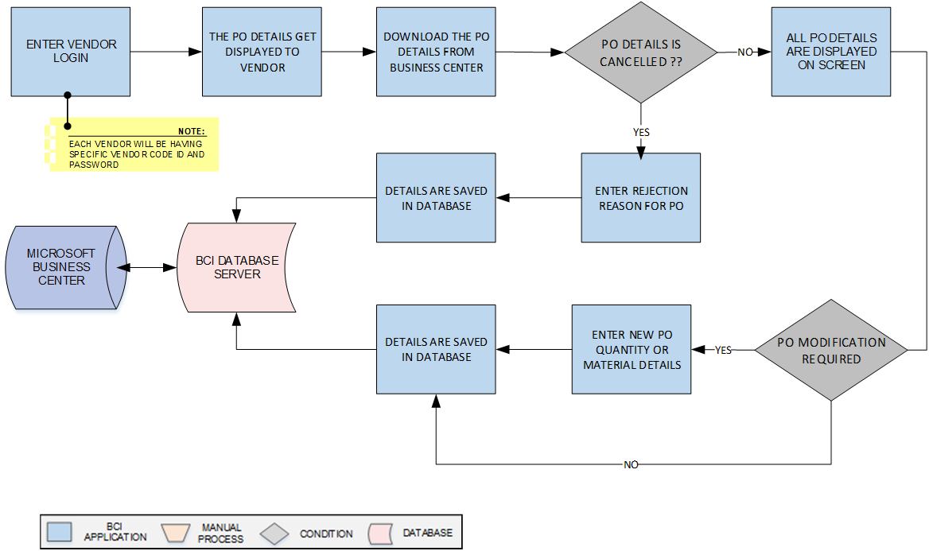

**Activities**

|  |  |
| --- | --- |
| **Module Description** | This module will be used to download the PO details as per the vendor code login provided. If necessary, vendors have the option to approve or decline an order, and they may adjust the order quantity depending on the amount of inventory that is available inventory and update corresponding details in Microsoft business center.  ***\*This activity will be done using Web Application.*** |

|  |  |
| --- | --- |
| **Pre-Conditions** | 1. Vendor master should be available. 2. Vendor details should be maintained in Vendor master. 3. Purchase Order should be fetched from ERP. 4. Interface will be required to fetch Purchase Order details from ERP. |

|  |  |
| --- | --- |
| **Process Steps** | 1. Enter the Web login with the Credentials user. 2. The PO details get downloaded from the Microsoft Navision as per user. 3. The user can choose to Accept or Reject the Order. 4. If the Order is accepted, the system displays the Order details on the screen. 5. If the Order is rejected, the Vendor must enter a reason or remark for the rejection. 6. The user can modify the quantity. 7. If the Vendor wants to modify the quantity, they can enter the new quantity based on the available inventory. 8. The Vendor can then update the Order quantity and post the updated Order to Navision. 9. All corresponding details will be saved in Microsoft Business Center |

|  |  |
| --- | --- |
| **Post-Conditions** | 1. PO details to be already saved after changes into Microsoft Business Center. 2. Order download if required by the user in Csv format. |

|  |  |
| --- | --- |
| **Validations** | 1. An alert should be displayed in case Order details are missing in ERP system. 2. An alert should be displayed in case Material Codes are not available in list. |

### Label Printing- Primary Carton Printing

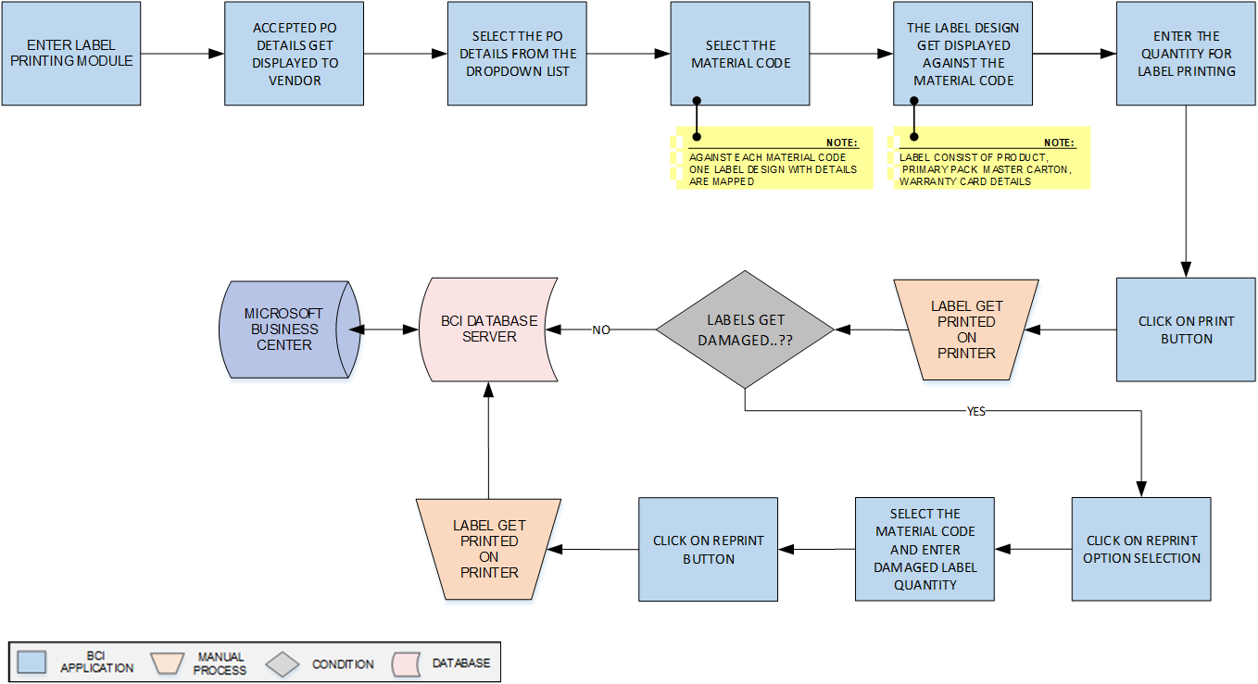

**Activities**

|  |  |
| --- | --- |
| **Module Description** | This module will be used to print barcode labels for material against Purchase Order & Material Code in order to provide unique identification to them and update corresponding details in database.  ***\*This activity will be done using Web Application.*** |

|  |  |
| --- | --- |
| **Pre-Conditions** | 1. Vendor details should be maintained in Vendor master. 2. The authorized quantity cannot be exceeded. 3. Accepted Purchase Order should be fetched from ERP. 4. Interface will be required to fetch Purchase Order details from ERP. |

|  |  |
| --- | --- |
| **Process Steps** | 1. The Label Printing Module is accessed by the User. 2. The system only displays details of accepted Purchase Orders (POs) on the screen. 3. Select the PO details from the list by selection box. 4. User then selects or enters the Material code against the selected PO details.   *\** *Each Material code is already mapped with a corresponding Primary label design.*  *\*\*The Label design include of Product details, Primary Pack, Master Carton and warranty card details.*   1. Enter Quantity of labels to be printed. 2. Click on the Print button, to generate barcode labels for the selected Material. 3. User paste the labels on corresponding material. 4. Update corresponding details in database and then to ERP.   **Reprinting Option Module**   1. Selects or Enter the Material code against the selected PO details. 2. Enter Quantity of labels to be printed. 3. Click the Re-Print button to create barcode labels for damaged labels. 4. The corresponding details get saved in database and then to ERP. |

|  |  |
| --- | --- |
| **Post-Conditions** | 1. Printing details will get saved in the database. 2. Material Code should be provided with label design in Label Master. 3. Damaged Barcode Labels will be reprinted by reprinting module. 4. Material will move for packing. 5. The inventory will not be updated until the packing is completed. |

|  |  |
| --- | --- |
| **Validations** | 1. An alert should be displayed in case duplicate/ invalid barcode is scanned. 2. An alert should be displayed in case Material Codes are not available in list. 3. An alert should be displayed in case invalid Material Code is selected. 4. An alert should be displayed in case Purchase Order details are not fetched from ERP. |

### Label Printing- Master Carton Printing



**Activities**

|  |  |
| --- | --- |
| **Module Description** | This module will be used to Master Carton Label print barcode labels for material against Purchase Order & Material Code in order to provide unique identification to them and update corresponding details in database.  ***\*This activity will be done using Web Application.*** |

|  |  |
| --- | --- |
| **Pre-Conditions** | 1. Vendor details should be maintained in Vendor master. 2. The authorized quantity cannot be exceeded. 3. Accepted Purchase Order should be fetched from ERP. 4. Interface will be required to fetch Purchase Order details from ERP. |

|  |  |
| --- | --- |
| **Process Steps** | 1. Select the Master Carton Label Printing Module. 2. The system only displays details of accepted Purchase Orders (POs) on the screen. 3. Select the PO details from the list by selection box. 4. User then selects or enters the Material code against the selected PO details.   *\** *Each Material code is already mapped with a corresponding Secondary label design.*   1. The label design mapped to the material code gets displayed from the Secondary Master Carton Label Design. 2. Enter the quantity of labels to be printed. 3. Click on the Print button to generate barcode labels for the selected material. 4. Paste the labels on the Master Carton Box. 5. . |

|  |  |
| --- | --- |
| **Post-Conditions** | 1. Printing details will get saved in the database. 2. Material Code should be provided with label design in Label Master. 3. The inventory will not be updated until the packing is completed. |

|  |  |
| --- | --- |
| **Validations** | 1. An alert should be displayed in case duplicate/ invalid barcode is scanned. 2. An alert should be displayed in case Material Codes are not available in list. 3. An alert should be displayed in case invalid Material Code is selected. 4. An alert should be displayed in case Purchase Order details are not fetched from ERP. |

### Master Carton Mapping

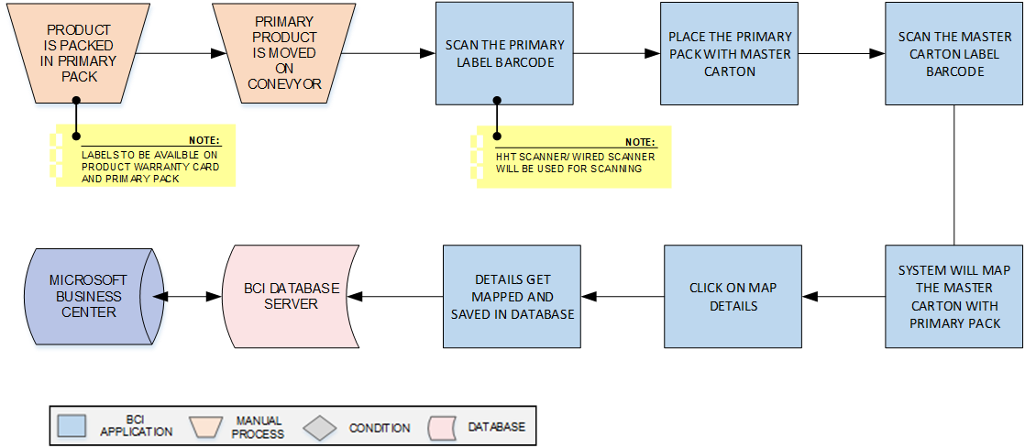

**Activities**

|  |  |
| --- | --- |
| **Module Description** | This module will help user to scan and pack material in Cartons as per pack size and print Shipper label for them; corresponding packing details will be updated in the database.  ***\*This activity will be done using Device Application.*** |

|  |  |
| --- | --- |
| **Pre-Conditions** | Material should have barcode labels. |

|  |  |
| --- | --- |
| **Process Steps** | 1. The Product is placed into the Primary Pack. 2. The packed carton is moved onto the conveyor. 3. The primary barcode label on the carton is scanned. 4. The Master Carton box is packed with the Primary pack. 5. The barcode label on the Master Carton is scanned. 6. The system maps the details of the Master Carton label and Primary carton label. 7. The user clicks on the Map button to confirm the details are correct. 8. The corresponding details are saved in the database and then to ERP |

|  |  |
| --- | --- |
| **Post-Conditions** | Shipper Barcode printing details will get saved in the database.  Packed Cartons will move for Dispatch. |

|  |  |
| --- | --- |
| **Validations** | 1. An alert should be displayed in case duplicate/ invalid barcode is scanned. 2. An alert should be displayed in case Material Code are not available in list. 3. An alert should be displayed in case invalid Material Code is selected. |

### Dispatch

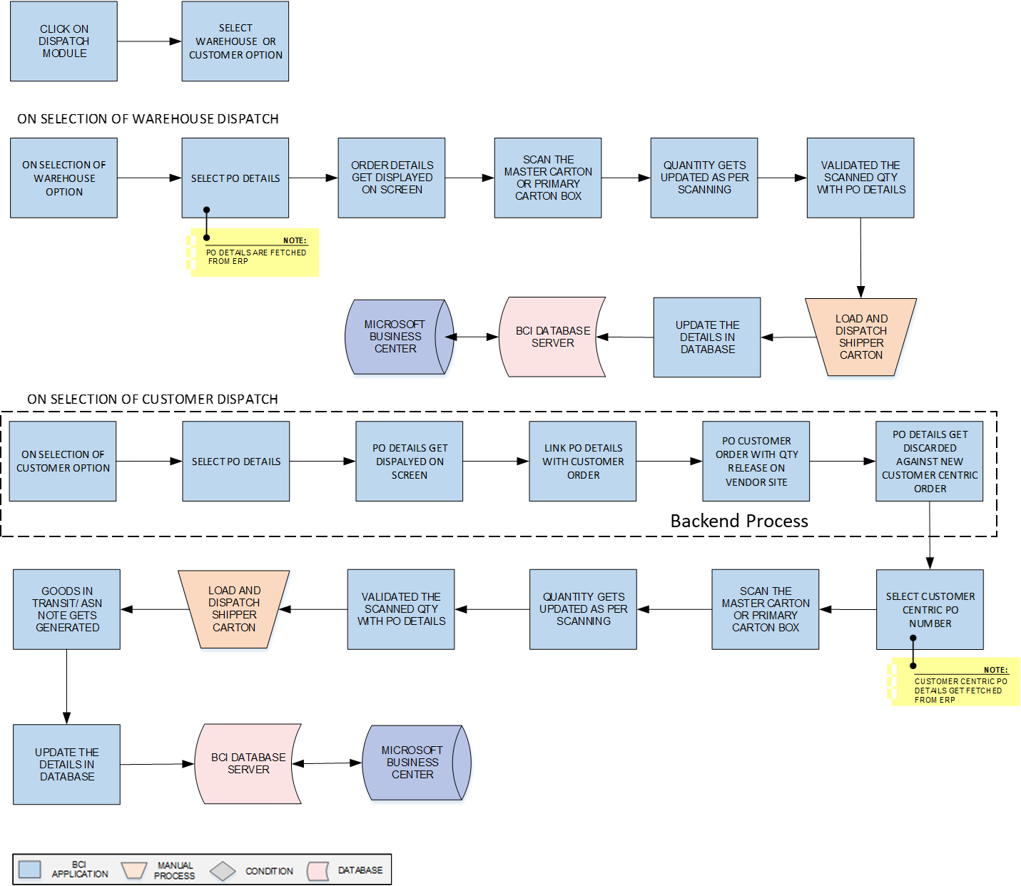

**Activities**

|  |  |
| --- | --- |
| **Module Description** | This module will help Vendor to dispatch Cartons (material) against received Purchase Order to Warehouse or Customer as per the Order. The Customer order can be delivered to Customer against Customer PO details as by changing the Shipping Order and to update the dispatch details in database.  ***\*This activity will be done using Device Application.*** |

|  |  |
| --- | --- |
| **Pre-Conditions** | Purchase Order should be available.  Cartons should have barcode label  Interface is required to fetch Purchase Order details from ERP. |

|  |  |
| --- | --- |
| **Process Steps** | 1. Enter the dispatch Module. 2. User can select the Warehouse/ Customer dispatch as per PO order.   **On Selection of Warehouse Dispatch**   1. Select the PO Order from the dropdown list. 2. Corresponding details such as Material Code, Quantity, Description, etc. appear on screen. 3. Scan the Master Carton/ Primary Carton barcode label. 4. Quantity gets updated as per the scan boxes. 5. Scan Shipper Carton label against PO.   *\*System will verify Shipper Carton against PO*  Repeat steps from 3 to 4 until all cartons against Purchase Order are scanned.   1. Load and dispatch Shipper Carton. 2. Update corresponding dispatch details in database.   **On Selection of Customer Dispatch**   1. Access the Customer Order details from the system. 2. Link the Customer Order details with the Purchase Order details. 3. Release the updated Purchase Order with new quantity on Vendor Site. 4. Discard the old Purchase Order details against the updated Customer Order details. 5. Select the Customer Order Number from the dropdown list. 6. Corresponding details such as Material Code, Quantity, Description, etc. appear on the screen. 7. Scan the Master Carton/ Primary Carton barcode label. 8. Quantity gets updated as per the scan boxes. 9. Scan Shipper Carton label against Customer PO details.   *\*System will verify Shipper Carton against Customer details.*  Repeat steps from 7 to 8 until all cartons against Purchase Order are scanned.   1. Load and dispatch Shipper Carton. 2. Update corresponding dispatch details in database. |

|  |  |
| --- | --- |
| **Post-Conditions** | Transaction details are saved in database.  Loaded material will be dispatched to Plant/ Warehouse. |

|  |  |
| --- | --- |
| **Validations** | 1. An alert should be displayed in case access Qty is been scanned against the PO details. 2. An alert should be displayed in case duplicate/ invalid Carton is scanned. 3. Alert should be displayed if Purchase Order Number is not available in list. |

## Warehouse Operation

### Receiving

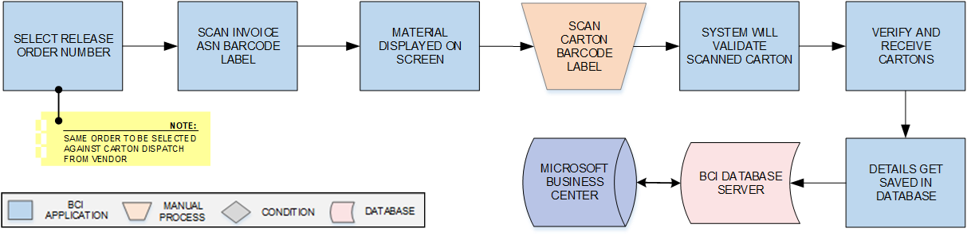

**Activities**

|  |  |
| --- | --- |
| **Module Description** | This module will let user to scan & receive carton Release Purchase Order from Vendors and the inventory details will be updated in the database.  ***\*This activity will be done using Device Application.*** |

|  |  |
| --- | --- |
| **Pre-Conditions** | 1. Cartons shall be received at warehouse. 2. Carton label should be present. |

|  |  |
| --- | --- |
| **Process Steps** | 1. Select the Barcode Release Order from the dropdown list. 2. Scan the ASN barcode label to display the material details on the screen. 3. Verify the details of the material displayed. 4. Scan the Carton Label of the arriving Cartons. 5. Receive the Cartons and verify their contents. 6. Save the details of the received Cartons in the database. |

|  |  |
| --- | --- |
| **Post-Conditions** | Inventory details will get updated in database. |

|  |  |
| --- | --- |
| **Validations** | 1. An alert should be displayed in case duplicate/ invalid barcode label is scanned. 2. An alert should be displayed in case of invalid activity. |

### Location Marking

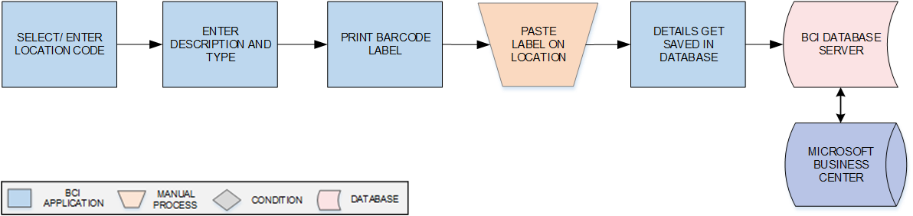

**Activities**

|  |  |
| --- | --- |
| **Module Description** | This module will be used to provide unique identification to the each locations of warehouse by printing serialized barcode labels for them.  ***This activity will be done using device Application.*** |

|  |  |
| --- | --- |
| **Pre-Conditions** | 1. Location master should be available. 2. Location details should be saved in Location master. |

|  |  |
| --- | --- |
| **Process Steps** | Select/Enter Location Code from dropdown list.  Corresponding Location details i.e. Location Type, Description, Zone, etc. will appear on screen.  *\*Location details will be fetched from Location Master.*  Print barcode labels against selected Location  Paste labels on Location.  Update details in database. |

|  |  |
| --- | --- |
| **Post-Conditions** | 1. Printing details will get saved in the database. |

|  |  |
| --- | --- |
| **Validations** | 1. An alert should be displayed in case Location Codes are not available in list. 2. An alert should be displayed invalid Location Code is entered/ selected. 3. An alert should be displayed in case Location details are not fetched from Location Master. |

### Putaway

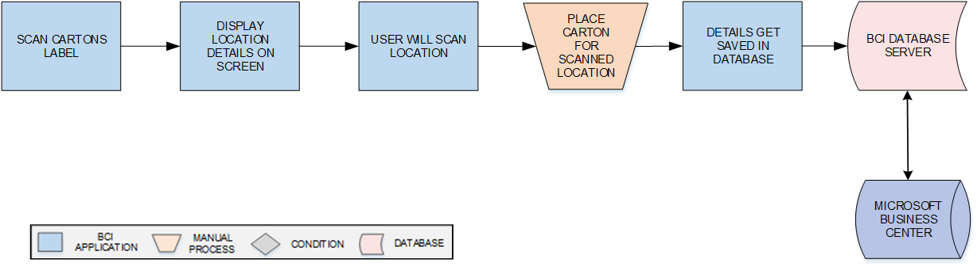

**Activities**

|  |  |
| --- | --- |
| **Module Description** | The module will be used to place the Cartons on storage location suggested by System and to update the Location-Carton mapping details in database.  ***\*This activity will be done using Device Application.*** |

|  |  |
| --- | --- |
| **Pre-Conditions** | Location Label should be printed using the Location Identification module   1. Location Code and Location Type should be defined in Master. 2. Cartons should have barcode labels. 3. HHT device should be available. |

|  |  |
| --- | --- |
| **Process Steps** | Scan Carton barcode label.  System will display location where carton needs to be placed.  Scan Location Barcode label.  *\*Location could be Ground level/ Racks.*  Place the Carton at scanned Location  Location – Carton mapping details will be updated in the database. |

|  |  |
| --- | --- |
| **Post-Conditions** | 1. Location-Carton mapping will be stored in database. |

|  |  |
| --- | --- |
| **Validations** | 1. An alert should be displayed in case user scan other location than defined or suggested Location. 2. An alert should be displayed in case duplicate / invalid barcode label is scanned. 3. Location-Item category mapping data should be updated in database. |

### Picklist Creation

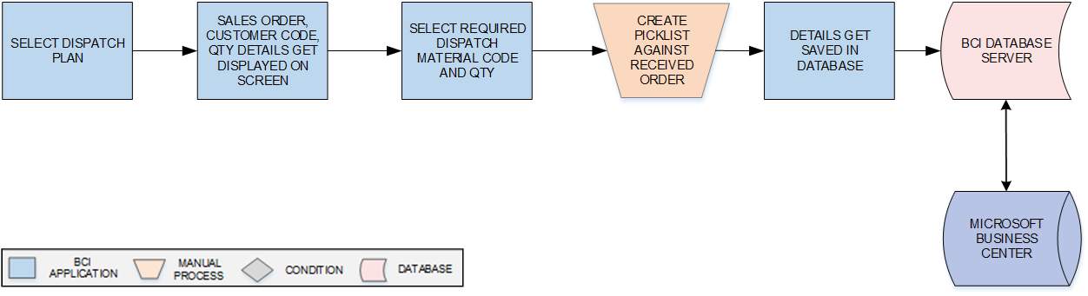

**Activities**

|  |  |
| --- | --- |
| **Module Description** | In this module, the Picklist will be generated against Dispatch Plan and a unique Picklist ID will be returned. The Dispatch Plan will be fetched from ERP.  ***\*This activity will be done using Web Application.*** |

|  |  |
| --- | --- |
| **Pre-Conditions** | 1. Dispatch plan should be fetched from ERP. 2. Interface will be required to fetch Dispatch Plan from ERP. |

|  |  |
| --- | --- |
| **Process Steps** | 1. Select Dispatch Plan.   *\*Dispatch Plan will be received from ERP.*  Sales Order No., Material Code, Customer Code, Quantity, etc. will appear on screen.  Select/ enter Material Code, Quantity.  Generate Picklist against selected Dispatch Plan.  Picklist ID will get displayed on screen.  Update details in database. |

|  |  |
| --- | --- |
| **Post-Conditions** | 1. Picklist ID will get generated by system. 2. User should be able to view the Picklist while Picking. |

|  |  |
| --- | --- |
| **Validations** | 1. An alert should be displayed in case of invalid activity. 2. System shall generate unique Picklist ID. |

|  |  |
| --- | --- |
| **Data Required from Microtek** | 1. Interface will be required to fetch Dispatch Plan details from ERP and same will be provided by Microtek. |

### Picking

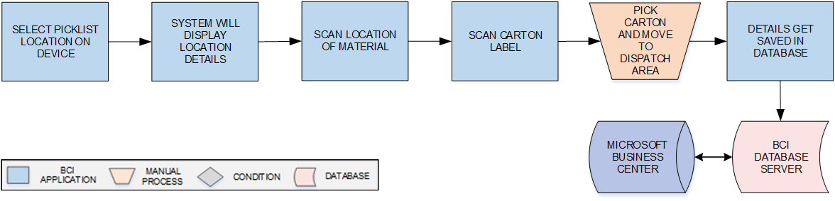

**Activities**

|  |  |
| --- | --- |
| **Module Description** | This module will allow user to scan and pick the FG material carton against Picklist from the location suggested by system. System will verify the Carton against Picklist and details for the same will be updated in database.  ***\*This activity will be done using Device Application.*** |

|  |  |
| --- | --- |
| **Pre-Conditions** | Picklist should be created   1. Carton should have barcode label. 2. Picklist ID should be available in list. 3. HHT device should be available. |

|  |  |
| --- | --- |
| **Process Steps** | 1. Select the Picklist ID in HHT. 2. Picklist details i.e. Quantity, Location Code, etc. will get displayed on screen. 3. Scan Location Barcode Label against Picklist. 4. Scan Carton Barcode Label against Picklist. 5. User will pick Carton from scanned Location. 6. Save details in the database. |

|  |  |
| --- | --- |
| **Post-Conditions** | Carton which are picked will move for Dispatch.   1. Inventory should get updated as per picking. |

|  |  |
| --- | --- |
| **Validations** | 1. An alert should be displayed in case duplicate/ invalid barcode is scanned. 2. An alert should be displayed if Picklist is not available in list. 3. An alert should be displayed if wrong Carton is scanned. 4. An alert will be displayed if Picked quantity entered is more than the quantity displayed in Picklist. |

### Dispatch

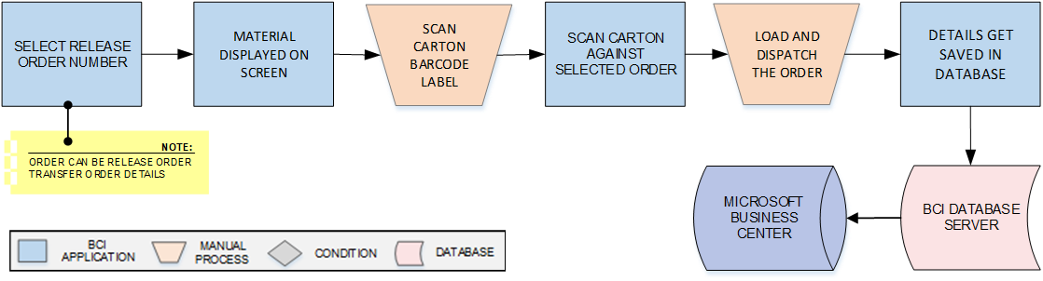

**Activities**

|  |  |
| --- | --- |
| **Module Description** | In this process, Cartons will be scanned and dispatched against Dispatch Plan and details for the same will get updated in database.  ***\*This activity will be done using Device Application.*** |

|  |  |
| --- | --- |
| **Pre-Conditions** | Dispatch Plan should be available  Interface will be required to fetch Dispatch Plan from ERP.  Picking should be complete. |

|  |  |
| --- | --- |
| **Process Steps** | Select Release Order Number in HHT.  Carton details such as Such as Material Code, Qty., Customer Code, etc. will appear.  Scan Carton Shipper Label against Dispatch plan.  Repeat steps from 1 to 3 until all cartons against Dispatch Plan are scanned.  Load and dispatch scanned Carton.  Update dispatch details in the database. |

|  |  |
| --- | --- |
| **Post-Conditions** | 1. Transaction details are saved in database. |

|  |  |
| --- | --- |
| **Validations** | 1. An alert should be displayed in case duplicate/ invalid carton is scanned.   Alert should be displayed if Dispatch Plan is not available in list. |

### Sales Return

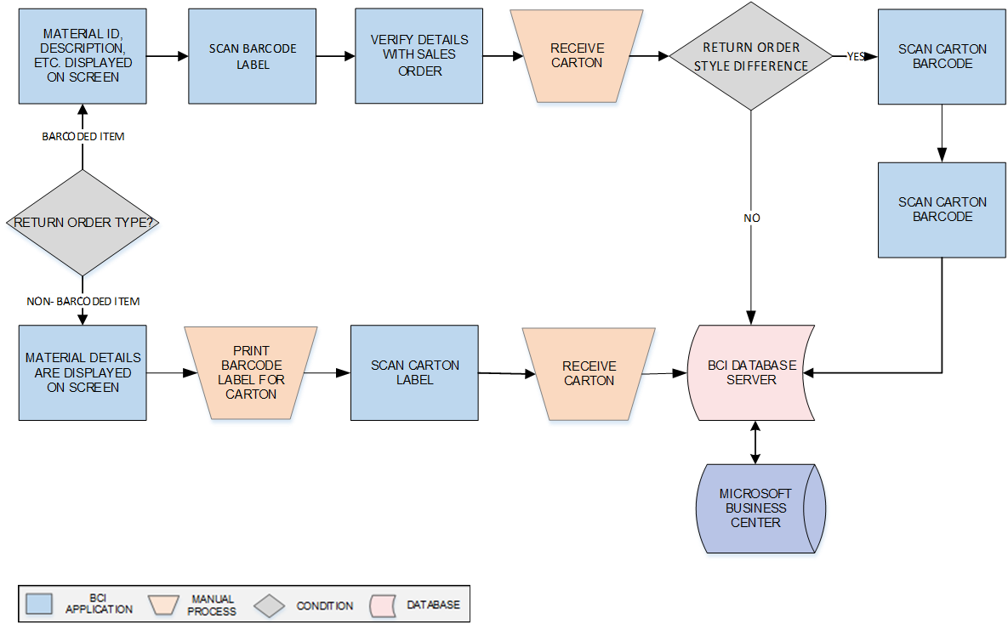

**Activities**

|  |  |
| --- | --- |
| **Module Description** | In this module items are received back in warehouse from Customer. Return stock details will be updated in the database.  ***\*This activity will be done using Device Application.*** |

|  |  |
| --- | --- |
| **Pre-Conditions** | 1. Material is received to warehouse. |

|  |  |
| --- | --- |
| **Process Steps** | 1. Enter/Select Return Order.   *\*Order will be received from Navision*   1. Material details such as Material ID, Description, etc. are displayed on screen 2. If barcoded item is received    1. Scan Carton barcode label    2. System will verify details against selected Order    3. Receive carton 3. If non-barcoded item is received    1. Print barcode label for Carton    2. Scan Carton label    3. Receive carton 4. If return item is due to Style Difference    1. Check the checkbox Style Difference    2. Scan Carton barcode    3. Receive carton 5. Corresponding details will get saved in database |

|  |  |
| --- | --- |
| **Post-Conditions** | 1. Order return Inventory will get updated. |

|  |  |
| --- | --- |
| **Validations** | 1. An alert should be displayed in case duplicate/ invalid Return Order entered/selected. 2. An alert should be displayed in case of invalid activity. 3. An alert should be displayed in case duplicate/ invalid barcode label is scanned. |

### Warehouse Transfer

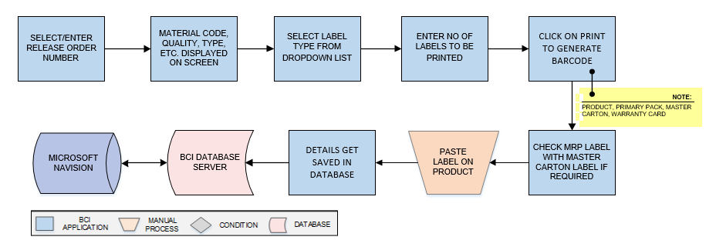

**Activities**

|  |  |
| --- | --- |
| **Module Description** | In this module cartons will be transferred from one warehouse to another. And details get updated in the database.  ***\*This activity will be done using Device Application.*** |

|  |  |
| --- | --- |
| **Pre-Conditions** | 1. GET_API is required to fetch the Release Order details from ERP. |

|  |  |
| --- | --- |
| **Process Steps** | 1. Enter/ Select Release Order Number   *\*Order will be received from ERP and could be Transfer Order.*   1. Material details such as Material Code, Quantity, Type, etc. on screen 2. Select label type from dropdown. 3. Enter No of label to be printed. 4. Print Barcode label. 5. Scan Cartons against selected Order   *\*Multiple Orders can be consolidated, if required.*   1. Load and dispatch to intended destination warehouse 2. Corresponding details will get saved in database 3. Post order dispatch details to Navision |

|  |  |
| --- | --- |
| **Post-Conditions** | 1. The material is transferred from one warehouse to another. |

|  |  |
| --- | --- |
| **Validations** | 1. An alert should be displayed in case duplicate/ invalid Release Order entered/selected. 2. An alert should be displayed in case duplicate/ invalid barcode label is printed. |

### Vendor Return

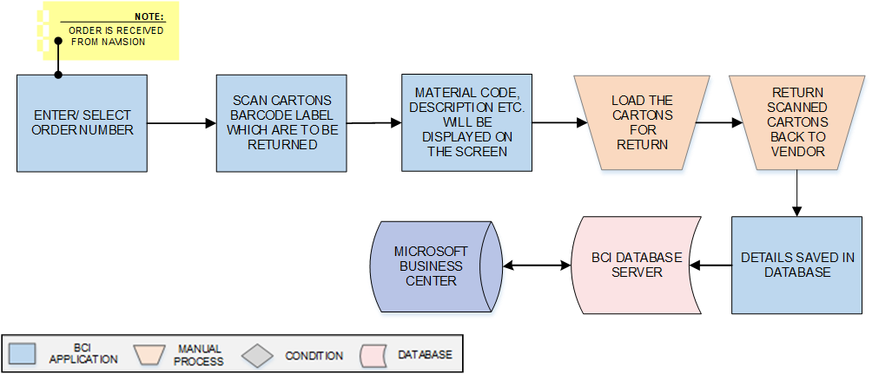

**Activities**

|  |  |
| --- | --- |
| **Module Description** | In this process, items which are damaged/ defective can be returned to Vendor and stock will be updated for the same in warehouse  ***\*This activity will be done using Device Application.*** |

|  |  |
| --- | --- |
| **Pre-Conditions** | 1. The return material order details will only be viewed. |

|  |  |
| --- | --- |
| **Process Steps** | 1. Enter/ select Order Number.   *\*Order is received from Navision.*   1. Scan Cartons barcode label which are to be returned. 2. Material details such as Material Code, Description etc. will be displayed on the screen. 3. Load the cartons for return. 4. Return scanned Cartons back to Vendor. 5. Corresponding details will get saved in database |

|  |  |
| --- | --- |
| **Post-Conditions** | 1. Cartons will be loaded and returned to vendor. |

|  |  |
| --- | --- |
| **Validations** | 1. An alert should be displayed in case duplicate/ invalid Order Number is entered/selected. 2. An alert should be displayed in case duplicate/ invalid canton barcode label is scanned. |

## Reports

Reporting module will provide access to the data that will be helpful in making well-informed strategic decisions, reduces risk, and increases productivity. The reporting interface will be user-friendly, application users can easily generate, and view required data.

The application will generate customized reports based on required data fields and time interval selected / entered by users; Microsoft Crystal Reports/ RDLC Reports will be generated which can be exported into defined excel file/ PDF format as and when required. There would be customized reports provided to End Users.

Reports can be defined as private for restricted viewing – or made public, giving access to information based on access rights assigned to the particular user / group.

# SRS Scope Change Process

## Before Sign Off

Any changes in SRS need to be informed in writing by Singer India Ltd. It will be incorporated / confirmed only after doing detailed feasibility study by BCI.

* If any change is out of scope then this would be done as a CR post feasibility and priority will be decided based on mutual agreement.
* Once the change is developed , any further change in the same would be considered as a CR

## After Sign Off

Any changes in proposed solution after approval of this document by Singer India Ltd. are subjected to confirmation from BCI, taking feasibility constraints into account. These changes will be incorporated (if any) into the solution only after delivering proposed solution & may be charged as extra.

* Any change in the proposed solution due to customer system design or process will be considered as CR
* Any process which is not mentioned in this document will not be considered as “mutual understanding or default presence or standard practice”.

The changes in proposed solution before & after acceptance will be mutually agreed and duly signed and accepted by Singer India Ltd. & BCI.

## SRS Acceptance

|  |  |
| --- | --- |
| **For Singer India Limited** | **For Bar Code India (BCI)** |
| **Name:** | **Name:** |
| **Designation:** | **Designation:** |
| **Department:** | **Department:** |

Agreed and Accepted by Singer India Ltd. and Bar Code India